Industrial Automation Projects
Engineering student projects for B.Tech and M.Tech final year students. Takeoff Edu Group offers a wide range of projects best for industrial automation projects looking for magnificent final projects at low cost.

We have successfully delivered computer science engineering projects to our engineering students. Our programs are specially designed by experts for best results of computer science engineering projects for engineering students. max of the B.Tech, M.Tech, PhD and Diploma scholars.

Takeoff Edu Group provides the most creative conceptions and ideas that can make very effective final year projects for scholars, experimenters, and engineers. So browse through our list of industrial automation projects and choose the smart final year projects for your requirements moment

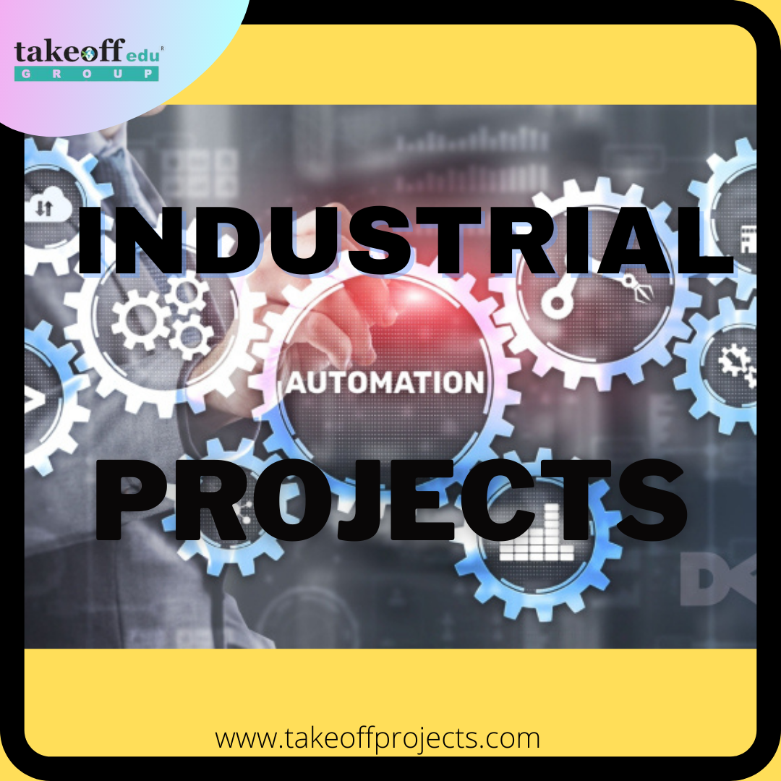
Industrial Engineering is the optimization of industrial processes for increased productivity using produce optimization, expenditure reduction, industry robotization and other approaches.

Assiduity robotization involves automating artificial work/ processes to either upgrade product volume or quality. Artificial robotization doesn't inescapably involve operation of automatic ministry or robotic arms. It may also involve the simply involve adding conveyor belt to speed up internal movement of goods or using 2 workers rather of one on a time consuming task to increase product.

Industrial Projects Assiduity Robotization can be best understood with the help of artificial systems. Then are exemplifications of artificial systems that automate artificial product.

